This document details how to change the Terms and Conditions document that is accessed from the ‘Terms of Use’ link on the public Recruitment page and the terms and conditions link that can be accessed from the applicant account prior to submitting an application.

Contents

1. Uploading the new documents 1
2. Deleting the previous versions 4

Knowledge Article: Online recruitment application forms

Personnel > Recruitment > Reference > General Document Management

Uploading the new documents

 | NB: The same document needs to be loaded twice; once for each Document Type ‘Terms and Conditions’ and ‘Submission Guidelines’.

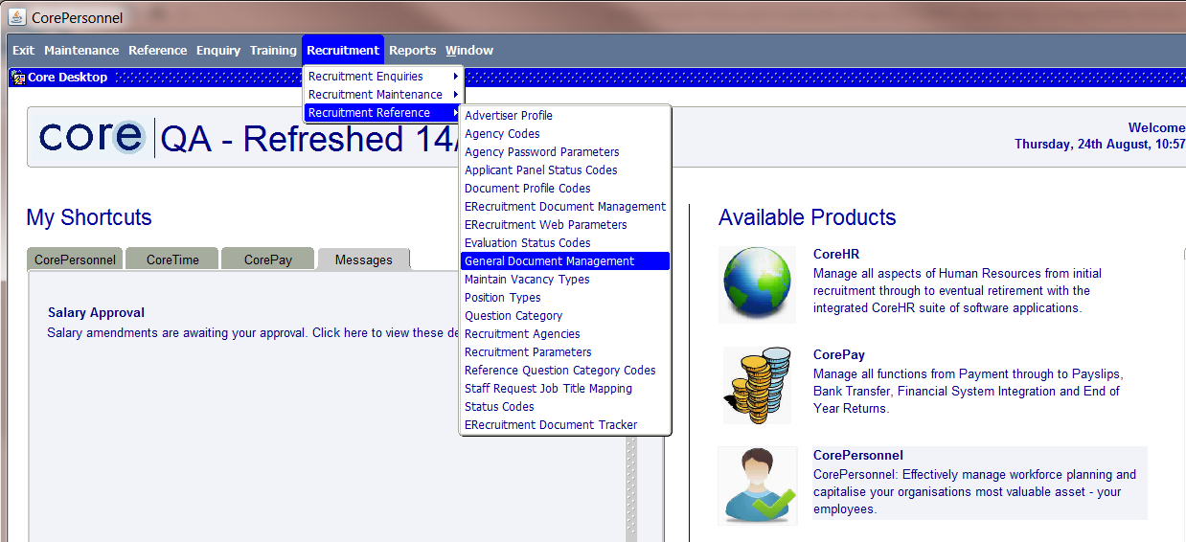

- Select Company – 10 ‘University of Oxford’ and Form Profile ERECRUIT - ‘E-Recruitment Form’.

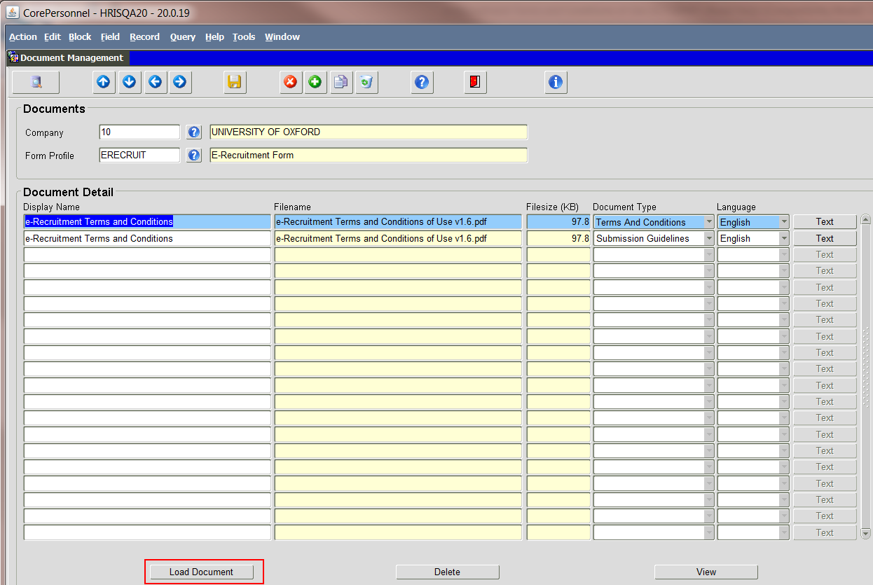

- Click on the Load Document button.

The following message will appear. Ignore it at this stage.

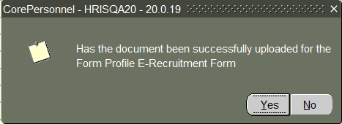

- Find the browser window that will have opened in whatever browser you are using as below:

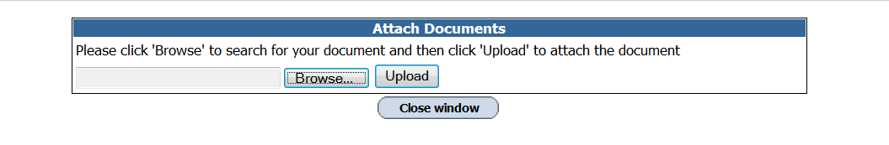

- Browse and select the relevant PDF document and Upload.

 | NB: You may need to use a shorter file path; the file name must not be longer than 44 characters.

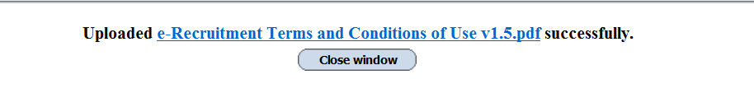

- Return to the Document Management screen and select Yes to the message if the document has loaded successfully.

- Amend the Display Name if required.

- Repeat steps 2 to 6 to upload the second document.

- Change the Document Type to blank on the previous versions.

- Update the Document Type on the new documents, one to ‘Terms and Conditions’ and one to ‘Submission Guidelines’.

- Save.

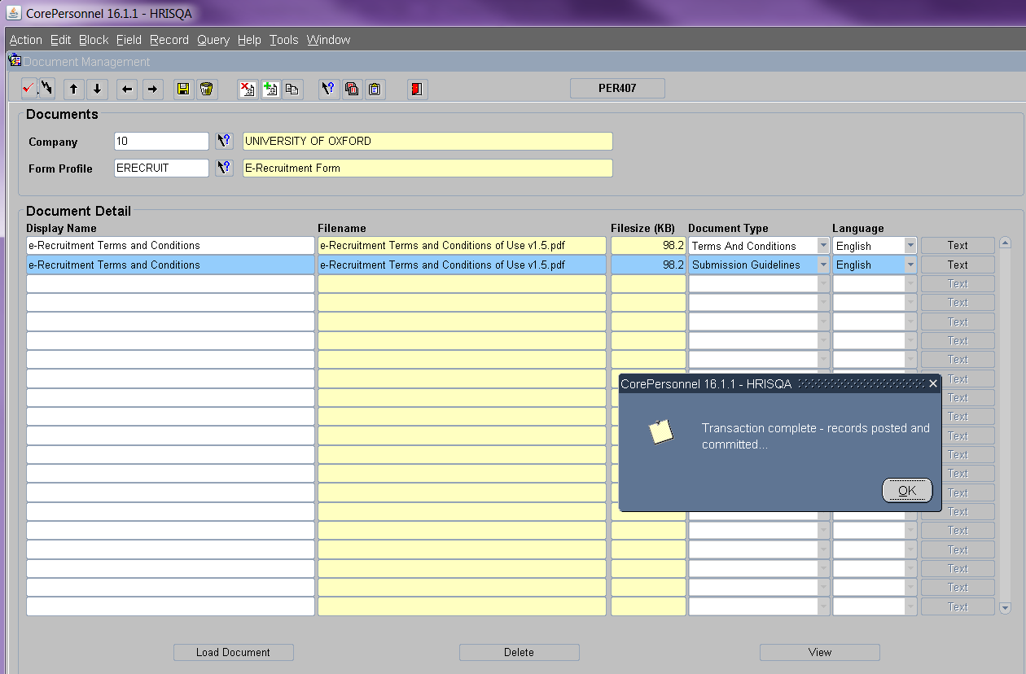

Deleting the previous versions

- Highlight one of the old versions and click on Delete.

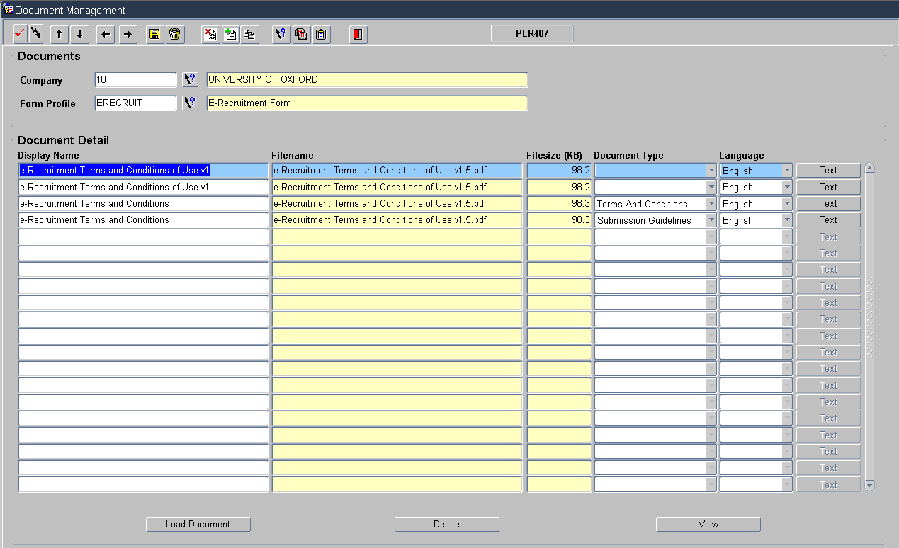

- A warning message will appear – Click Yes to confirm.

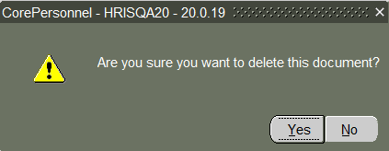

- A confirmation message will appear. Click OK.

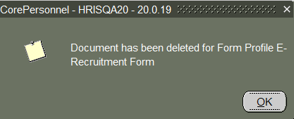

- Repeat steps 11 and 12 to delete the second old version.

